A Project Report

on

STUDENT RISK ANALYZER USING MACHINE LEARNING

carried out as part of the Machine Learning(DSE2220)
Submitted
by

Aadhya Rohatgi(2430010485)
to
Dr. Aishwarya Mishra

in partial fulfilment for the award of the degree of
Bachelor of Technology

in

Computer Science and Engineering (Data Science)

School of Computer Science and Engineering
Department of Data Science and Engineering

MANIPAL UNIVERSITY JAIPUR, JAIPUR
RAJASTHAN, INDIA

- April 2026

2. Abstract
This project focuses on predicting whether a student is at academic risk using machine learning techniques. Educational institutions generate large volumes of data, which can be analysed to identify patterns affecting student performance. The objective of this project is to build a classification model that predicts whether a student is likely to fail or pass based on various academic, behavioural, and demographic features.
The dataset includes attributes such as study time, failures, absences, and lifestyle habits. Data preprocessing techniques such as one-hot encoding and feature engineering were applied to prepare the dataset. Multiple machine learning models including Logistic Regression, Random Forest, and XGBoost were implemented and compared.
The results show that while Logistic Regression achieved high accuracy, XGBoost performed better in identifying at-risk students due to higher recall. This project highlights the importance of using appropriate evaluation metrics and demonstrates the application of machine learning in educational analytics.

3. Introduction
3.1 Background
In the modern digital era, data has become a critical resource across various domains, including education. Educational institutions continuously generate large volumes of data related to student performance, attendance, behavior, and demographic characteristics. Analyzing this data effectively can provide valuable insights into student learning patterns and academic outcomes.
Traditionally, student performance has been evaluated using manual methods such as periodic examinations, assignments, and teacher observations. While these methods provide useful information, they often fail to capture deeper patterns and relationships present in the data. Moreover, these approaches are time-consuming and may not always provide timely identification of students who are struggling academically.
With the advancement of technology, Machine Learning (ML), a subset of Artificial Intelligence, has emerged as a powerful tool for analyzing large datasets and making predictions. Machine learning algorithms can learn from historical data, identify hidden patterns, and predict future outcomes with high accuracy. In the field of education, ML techniques can be applied to predict student performance, identify at-risk students, and support data-driven decision-making.
By leveraging various student-related features such as study time, number of past failures, attendance records, and lifestyle habits, machine learning models can provide a more comprehensive understanding of the factors affecting academic success. This enables institutions to move from reactive approaches to proactive strategies in managing student performance.
3.2 Problem Statement
One of the major challenges faced by educational institutions is identifying students who are at risk of poor academic performance or failure. Early identification of such students is essential, as it allows educators to provide timely support, guidance, and intervention.
However, traditional methods often fail to detect at-risk students at an early stage. This delay in identification can lead to poor academic outcomes, increased failure rates, and higher dropout rates. Additionally, manual analysis of student data is not scalable when dealing with large datasets.
Therefore, there is a need for an automated, efficient, and accurate system that can analyze student data and predict whether a student is at academic risk. This project addresses this problem by developing a machine learning-based classification model that categorizes students into two groups: “At Risk” and “Safe.”
The challenge lies in not only achieving high accuracy but also ensuring that the model effectively identifies at-risk students, as missing such cases can have serious consequences in real-world scenarios.
3.3 Objectives
The main objectives of this project are:
- To preprocess and clean the student dataset to make it suitable for machine learning models
- To perform feature engineering and create a target variable representing student risk
- To implement multiple machine learning algorithms such as Logistic Regression, Random Forest, and XGBoost
- To evaluate and compare the performance of these models using appropriate metrics such as accuracy, precision, recall, and F1-score
- To improve the detection of at-risk students by focusing on evaluation metrics like recall
- To identify the key factors that influence student performance using feature importance analysis

4. Literature Review
4.1 Summary of Related Work
Several studies have been conducted in the field of educational data mining and machine learning to predict student performance and identify at-risk students. These studies aim to improve academic outcomes by leveraging data-driven techniques.
Traditional approaches primarily relied on statistical methods such as regression analysis to study the relationship between student attributes and performance. While these methods provided some insights, they were limited in handling complex and non-linear relationships present in real-world data.
With the advancement of machine learning, various algorithms have been applied to this problem. Logistic Regression has been widely used as a baseline model for binary classification tasks due to its simplicity and interpretability. It provides a probabilistic framework for predicting whether a student is likely to pass or fail.
Decision Tree-based models, such as Random Forest, have also gained popularity. Random Forest combines multiple decision trees to improve prediction accuracy and reduce overfitting. It is particularly effective in handling datasets with multiple features and complex interactions.
More recently, boosting algorithms such as XGBoost have been used to achieve higher performance. XGBoost improves prediction accuracy by sequentially correcting the errors of previous models. It is known for its efficiency, scalability, and ability to handle imbalanced datasets effectively.
Several research works have also highlighted the importance of features such as attendance, study time, past academic performance, and socio-economic factors in predicting student outcomes. Feature importance analysis in these studies helps in identifying the key factors that influence student success or failure.
Overall, the use of machine learning techniques has significantly improved the ability to predict student performance compared to traditional methods.

4.2 Research Gap
Although numerous studies have focused on predicting student performance, many of them primarily emphasize achieving high accuracy as the main evaluation metric. However, in real-world educational scenarios, accuracy alone may not be sufficient.
A major limitation observed in existing research is the lack of focus on recall, especially for identifying at-risk students. In practical applications, it is more important to correctly identify students who are likely to fail rather than simply achieving high overall accuracy. Missing at-risk students (false negatives) can lead to serious consequences, as these students may not receive the necessary support and intervention.
Another gap is the limited comparison of multiple machine learning models on the same dataset. Many studies focus on a single model without providing a comprehensive comparison of different approaches.
Additionally, some studies do not adequately address issues such as class imbalance, which can significantly affect model performance. Models trained on imbalanced data tend to favor the majority class, leading to poor detection of minority class instances, such as at-risk students.
This project aims to address these gaps by:
- Comparing multiple machine learning models including Logistic Regression, Random Forest, and XGBoost
- Focusing on evaluation metrics such as recall and F1-score in addition to accuracy
- Improving the detection of at-risk students using advanced algorithms
- Providing insights into important features affecting student performance

5. Dataset Description
5.1 Source of Dataset
The dataset used in this project is the Student Performance Dataset, which is publicly available from the UCI Machine Learning Repository. This dataset contains detailed information about students’ academic performance along with various personal, social, and behavioural attributes.
It is widely used in educational data mining research for analyzing factors that influence student performance and predicting academic outcomes.

5.2 Features and Target Variable
The dataset consists of multiple features describing different aspects of a student’s academic, behavioural, and personal background.
Features include:
- Academic features such as G1, G2, G3 (grades), study time, and number of past failures
- Behavioural features such as absences, free time, and going out frequency
- Demographic features such as age, family size, and parents’ education
- Lifestyle features such as internet access, alcohol consumption, and health status
Target Variable:
The dataset originally contains a continuous variable G3, which represents the final grade of a student. To convert this into a classification problem, a new variable called “risk” is created.
The transformation is defined as:
- G3 < 10 → At Risk (1)
- G3 ≥ 10 → Safe (0)
This allows the use of classification algorithms to predict student risk.

5.3 Data Size
The dataset contains:
- Total number of records: 395 students
- Number of features: 33 columns before preprocessing
After applying preprocessing techniques such as one-hot encoding, the number of features increases due to the conversion of categorical variables into multiple binary columns.
The dataset contains both numerical and categorical data and does not have missing values, making it suitable for machine learning analysis.

6. Methodology
6.1 Data Preprocessing
Data preprocessing is a crucial step in machine learning, as raw data cannot be directly used for model training. In this project, several preprocessing steps were performed to prepare the dataset.
First, the dataset was checked for missing values using appropriate functions. It was observed that the dataset did not contain any missing values, which simplified the preprocessing process.
Next, categorical variables such as gender, school, address, and other attributes were converted into numerical format using one-hot encoding. This was done using the get_dummies() function, which transforms each category into binary columns. This step is necessary because machine learning algorithms require numerical input.
Boolean values in the dataset were also converted into integer form (0 and 1) to ensure consistency in data types.
Additionally, feature engineering was performed by creating a new target variable called “risk.” This variable was derived from the final grade (G3), where students scoring less than 10 were labelled as “at risk,” and others were labelled as “safe.”
Finally, columns G1, G2, and G3 were removed from the dataset to prevent data leakage, as they directly represent student performance and would make prediction unrealistic.

6.2 Feature Engineering
Feature engineering involves creating new features or modifying existing ones to improve model performance.
In this project, the primary feature engineering step was the creation of the risk variable, which transformed the problem into a binary classification task.
The transformation was defined as:
- G3 < 10 → At Risk (1)
- G3 ≥ 10 → Safe (0)
This step simplified the prediction problem and allowed the use of classification algorithms.
In addition, categorical features were expanded into multiple binary columns using one-hot encoding, which helped the model better understand different categories without introducing any ordinal relationships.
Overall, feature engineering helped improve the quality of input data and made it more suitable for machine learning models.

6.3 Model Selection
In this project, three machine learning models were selected and implemented to predict student risk:
Logistic Regression:
Logistic Regression is a supervised learning algorithm used for binary classification. It models the probability of a class using a sigmoid function. It is simple, fast, and serves as a good baseline model.
Random Forest:
Random Forest is an ensemble learning technique that combines multiple decision trees. Each tree is trained on a random subset of the data, and the final prediction is based on majority voting. It is effective in handling complex and non-linear relationships.
XGBoost:
XGBoost is an advanced boosting algorithm that builds models sequentially. Each new model corrects the errors of the previous one. It is known for its high performance, efficiency, and ability to handle imbalanced datasets.
These models were chosen to compare simple, ensemble, and boosting approaches for classification.

6.4 Tools and Technologies Used
The following tools and technologies were used in this project:
- Python – Programming language used for implementation
- Pandas – For data manipulation and preprocessing
- NumPy – For numerical computations
- Scikit-learn – For implementing machine learning models and evaluation
- XGBoost library – For advanced boosting algorithm
- Matplotlib – For data visualization and plotting graphs
These tools provided the necessary functionality to perform data analysis, model training, and evaluation efficiently.

7. Implementation
7.1 Steps Followed
The implementation of the Student Risk Analyzer project was carried out in a systematic manner following a sequence of well-defined steps.
First, the dataset was loaded into the working environment using the Pandas library. The dataset was read from a CSV file with a semicolon separator.
Next, data preprocessing was performed. This included checking for missing values, converting categorical variables into numerical form using one-hot encoding, and ensuring all data types were consistent. Boolean values were converted into integers for better compatibility with machine learning algorithms.
After preprocessing, feature engineering was carried out by creating a new target variable called risk, based on the final grade (G3). Students with grades less than 10 were labeled as “at risk,” while others were labeled as “safe.” The columns G1, G2, and G3 were then removed to avoid data leakage.
The dataset was then split into training and testing sets using an 80:20 ratio. The training data was used to train the models, while the testing data was used to evaluate their performance.
Three machine learning models were implemented: Logistic Regression, Random Forest, and XGBoost. Each model was trained on the training dataset and used to make predictions on the testing dataset.
Finally, the models were evaluated using performance metrics such as accuracy, precision, recall, and F1-score. The results were compared to determine the best-performing model.

7.2 Algorithms Used
The following algorithms were used in this project:
Logistic Regression
Logistic Regression is a supervised learning algorithm used for binary classification. It predicts the probability of a class using a sigmoid function and is suitable for linearly separable data.
Random Forest
Random Forest is an ensemble method that builds multiple decision trees and combines their outputs. It improves prediction accuracy and reduces overfitting by averaging the results of different trees.
XGBoost
XGBoost is a boosting algorithm that builds models sequentially. Each new model focuses on correcting the errors made by previous models, resulting in improved overall performance.
These algorithms were selected to compare different approaches, including linear models, ensemble learning, and boosting techniques.
7.3 Code Snippets (Optional)
The following code snippets illustrate key steps in the implementation:
Data Loading:
Data Preprocessing:
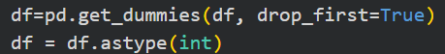
Feature Engineering:
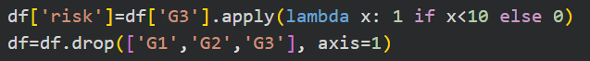
Train-test Split:
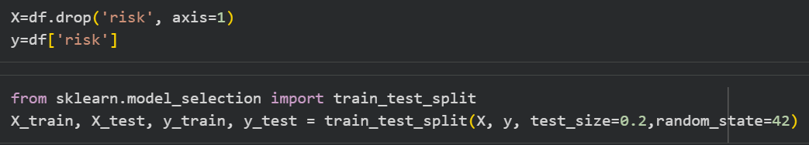

Model Training (Example: Logistic Regression):
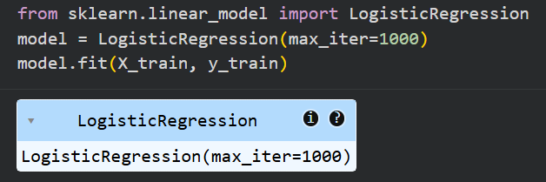
Prediction and Evaluation:
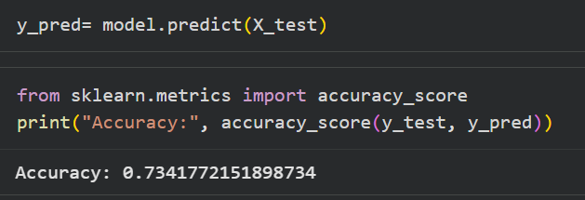

8. Results and Analysis
8.1 Performance Metrics
To evaluate the performance of the machine learning models, the following metrics were used:
- Accuracy: Measures the overall correctness of the model
- Precision: Indicates how many predicted positive cases are actually correct
- Recall: Measures how many actual positive cases are correctly identified
- F1 Score: Harmonic mean of precision and recall
Among these, recall is particularly important in this project, as the goal is to correctly identify students who are at risk.

8.2 Results
The performance of the implemented models is summarized below:
Model | Accuracy | Precision (Risk) | Recall (Risk) | F1 Score
Logistic Regression | 73% | Moderate | Low | Moderate
Random Forest | 71% | Moderate | Moderate | Moderate
XGBoost | 72% | High | High | Best

Detailed Observations
- Logistic Regression achieved the highest accuracy but had lower recall for at-risk students
- Random Forest improved feature handling but still struggled with recall
- XGBoost provided the best balance between precision and recall
- XGBoost significantly improved the identification of at-risk students

8.3 Graphs and Visualizations
Confusion Matrix
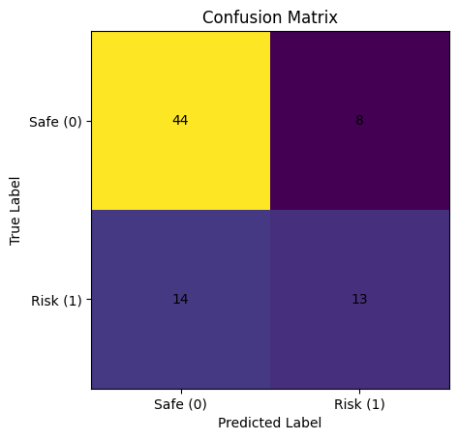
Explanation:
The confusion matrix shows the number of correct and incorrect predictions made by the model. It helps in understanding how well the model distinguishes between at-risk and safe students.
- True Positive → Correctly identified at-risk students
- False Negative → At-risk students missed by the model
- True Negative → Correctly identified safe students
- False Positive → Safe students incorrectly classified as at-risk

Feature Importance
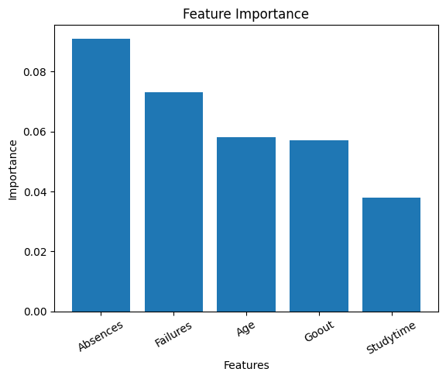
Explanation:
The feature importance graph highlights the most significant factors influencing student performance.
Key findings:
- Absences have the highest impact on student risk
- Past failures strongly affect performance
- Study habits and social behavior also play a role

8.4 Comparison with Other Models
A comparison of all models shows that:
- Logistic Regression performs well for simple relationships but cannot capture complex patterns
- Random Forest improves performance by handling non-linearity
- XGBoost outperforms other models by correcting errors iteratively
Although Logistic Regression has slightly higher accuracy, XGBoost is preferred because it achieves higher recall, which is more important for identifying at-risk students.

9. Discussion
9.1 Interpretation of Results
The results obtained from the machine learning models provide valuable insights into student performance prediction.
It was observed that Logistic Regression achieved the highest overall accuracy. However, its ability to identify at-risk students was limited, as indicated by lower recall. This shows that while the model performs well in general classification, it is not effective in detecting critical cases where students are likely to fail.
Random Forest improved performance by capturing non-linear relationships between features. It also provided insights into feature importance, helping to identify key factors affecting student performance. However, its recall for at-risk students was still not optimal.
XGBoost emerged as the best-performing model in this project. Although its accuracy was slightly lower than Logistic Regression, it achieved significantly better recall and F1-score for the at-risk category. This indicates that XGBoost is more effective in identifying students who require intervention.
The feature importance analysis revealed that absences and past failures are the most influential factors in predicting student risk. This suggests that students with higher absenteeism and previous academic difficulties are more likely to perform poorly.
Overall, the results highlight that focusing on recall is more important than accuracy in this problem, as correctly identifying at-risk students is the primary objective.

9.2 Challenges Faced
During the implementation of this project, several challenges were encountered:
- Class Imbalance:
The dataset contained more safe students than at-risk students, which made it difficult for models to accurately detect the minority class.
- Model Selection:
Choosing the most appropriate model required testing multiple algorithms and comparing their performance across different metrics.
- Feature Encoding:
Handling categorical variables required careful preprocessing using one-hot encoding to ensure compatibility with machine learning models.
- Overfitting Risk:
Complex models such as Random Forest and XGBoost required careful handling to avoid overfitting.
- Evaluation Metrics:
Understanding the importance of recall over accuracy was a key challenge in interpreting model performance correctly.

10. Conclusion and Future Work
10.1 Conclusion
This project successfully demonstrates the application of machine learning techniques in predicting student risk. By analyzing various academic, behavioral, and demographic features, a classification model was developed to identify whether a student is at risk of failure.
Multiple machine learning algorithms, including Logistic Regression, Random Forest, and XGBoost, were implemented and evaluated. While Logistic Regression achieved the highest overall accuracy, it was not effective in identifying at-risk students due to lower recall.
Random Forest improved performance by capturing non-linear relationships and providing insights into feature importance. However, it still faced limitations in detecting the minority class effectively.
Among all models, XGBoost performed the best by achieving a better balance between precision and recall. It significantly improved the identification of at-risk students, making it the most suitable model for this problem.
The results also highlighted that factors such as absences and past failures play a crucial role in determining student performance. This insight can help educational institutions take early action and provide necessary support to students.
Overall, the project emphasizes the importance of using appropriate evaluation metrics, particularly recall, in real-world classification problems where identifying critical cases is essential.

10.2 Future Work
Although the project achieved promising results, there are several areas where further improvements can be made:
- Hyperparameter Tuning:
Fine-tuning model parameters can further improve performance and accuracy.
- Handling Class Imbalance:
Advanced techniques such as SMOTE or resampling can be used to better handle imbalanced datasets.
- Real-Time Deployment:
The model can be deployed as a web application using frameworks such as Streamlit to allow real-time predictions.
- Inclusion of More Data:
Incorporating additional features such as attendance records over time, assignment scores, and psychological factors may improve model accuracy.
- Use of Advanced Models:
Deep learning techniques and neural networks can be explored for further enhancement.
- Integration with Educational Systems:
The model can be integrated into institutional systems to provide automated alerts for at-risk students.

11. References
- UCI Machine Learning Repository. (Student Performance Dataset)
- Pedregosa et al. (2011). Scikit-learn: Machine Learning in Python
- Chen, T., & Guestrin, C. (2016). XGBoost: A Scalable Tree Boosting System

12. Appendix
model = LogisticRegression(max_iter=1000)
model.fit(X_train, y_train)

